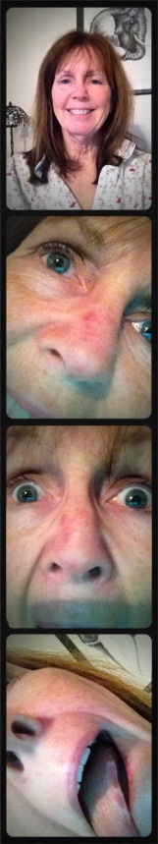
PHOTO BOOTH - Start the New Year with some PHOTO FUN!
Contact Sheet DUE
Project Photo DUE
*Remember that without a contact sheet, your photo will not be graded

Go to Google Images and do a search for “Photo Booth” or “Photo Booth Pictures” to see some examples of photos taken in a Photo Booth. (Check out backdrops, props, and ‘action’.)
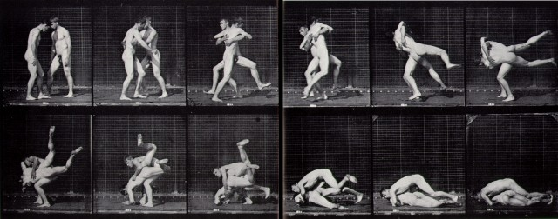

Think about how a sequence of images can show:
- MOVEMENT
- TIME ELAPSING
- CREATE A MOOD WITH ANTICIPATION

* The first photographer ever to investigate effects of still images in succession was EADWEARD MUYBRIDGE in the late 19th century when photography was in its infancy.

Use a camera, your phone, or an app to create a photo booth ‘strip’ of 3-4 photos in succession!

Use props, a theme, be silly, just have fun with friends . . .

Set up a BACKDROP . . .

Set your camera on a TRIPOD . . . (no tripod? Try a small bean bag or put some beans in a sock!)

Use the SELF TIMER . . . 

Use MULTIPLE EXPOSURES . . . 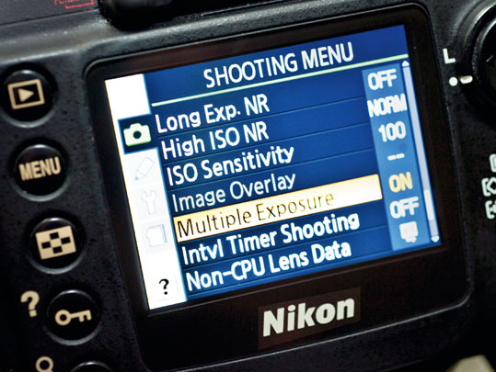

*Think about an EFFECT you want and try to make it happen!

CONTACT SHEET using camera OR app (‘pre-made’ or multiple photo strips as one image)
Art 100 – 15 photo strips, THREE IDEAS, 5 camera angles or strips
WOW! – 15 photo strips, TWO IDEAS, multiple camera angles of each
Accomplished – 15 various photos or photo strips; idea or theme apparent in some
Emerging – 15 photos/photo strips, no idea or theme apparent
Novice – fewer than 15 photos/photo strips

